Keeping Trails open for Future Generations”

www.bchng.org and we are on Facebook
Phone
(618) 638-4416 Robert Wagner - info (706) 455-2921 Melinda Wagner – Facebook submittals

January 2020 Newsletter

President: Robert (Bob) Wagner
Vice President: Martha Fillingham Secretary: Kathleen Corcoran Treasurer: Linda Richards

2020 Board of Directors

Billy Long 706-455-7663
Chuck Panter 706-455-7302
Dewey Campbell 706-271-6097
Henry Wyatt II 423-715-7847
Jeremy Kirby 706-264-4701
Kelly Mathis 706-633-8305
Melinda Wagner 706-455-2921
Molly Ford Campbell 706-889-5555
Sandra Stephenson 706-669-9021

January Board Meeting - Jan.28, 2020
February Board Meeting – Feb. 25, 2020
Location : Fannin County Senior Center
440 W. First St. Blue Ridge GA. 30513
Time; 06:30 pm

GENERAL MEETING
We intend on holding quarterly meetings, and our first for 2020 is scheduled for Feb 18th, 2020
Location : Fannin County Senior Center
440 W. First St. Blue Ridge GA. 30513
Time; 06:30 pm

DUES
Dues are due, please Remit to: Linda Richards (Treasure) Application/ Renewal form can be found online at
bchng.org

TRAIL ALERTS

BCHNG has Trail Crews staged out of Blue Ridge and Chatsworth. Please contact Robert Wagner –either call or text, 618-638-4416. The appropriate trail crew will be notified by him.
Information needed: Trail name ,day of report, GPS coordinates of problem area if possible, pictures are always good, Approximate distance from trail head or intersection. .

FIRST AID / CPR CLASSES
Schedule should be out soon – Check the Events calendar for Dates times and Location

CAMPGROUND WORK DAYS please see the events calendar on the website at bchng.org

Trash -JRF
Robert /Melinda | 6-Jan
Dewey /Molly | 13-Jan
Lakota /Kelly | 20-Jan
Tommy/Martha | 27-Jan

SCHEDULED TRAIL WORKDAYS
Events calendar on the web site.

RECON RIDES – JEREMY KIRBY, JUSTIN PATTERSON, CHUCK PANTER ,BILLY LONG,HENRY WYATT ll
Please submit ride information horsepacker47@yahoo.com as early as possible for the next month. Accepting FEB /MAR. INFO NOW.

POSITION OPENING

LOCAL SERVICE TEAM LEADER Cottonwood Patch Campground) Responsible for Campground workdays, reports directly to TRAIL WORKDAY COORDINATOR. Responsibilities include, but not limited to: Setting workdays, acquiring approval for CHAPTER funded cookout in conjunction with workday, insuring all participants hours are reported to Work Day Coordinator. Ensuring all receipts for authorized expenditures are sent to Treasurer for reimbursement and workday announcement is reported as early as possible to Website Coordinator for posting.
Thank you to Angelia Patterson for stepping up in 2019. We all know that our personal lives come first and at times Volunteerism must be put aside. If you live in the Chatsworth Area are willing to spend a couple hours a month on your computer, have organizational skills, we need you.
Please contact Melinda Wagner for information

COTTONWOOD PATCH
DEC 2019
RESOURCE DAMAGE

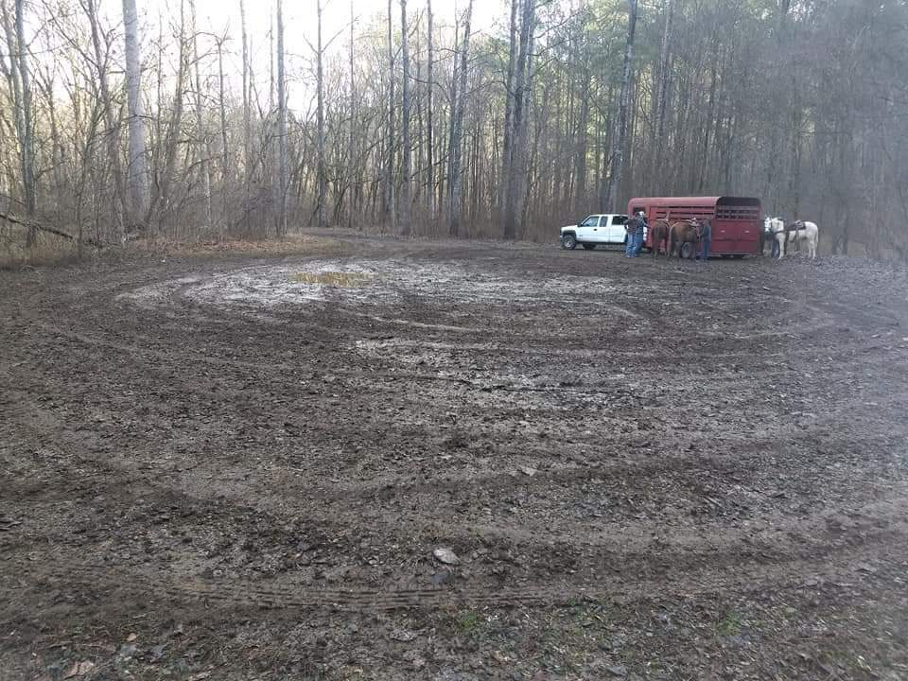

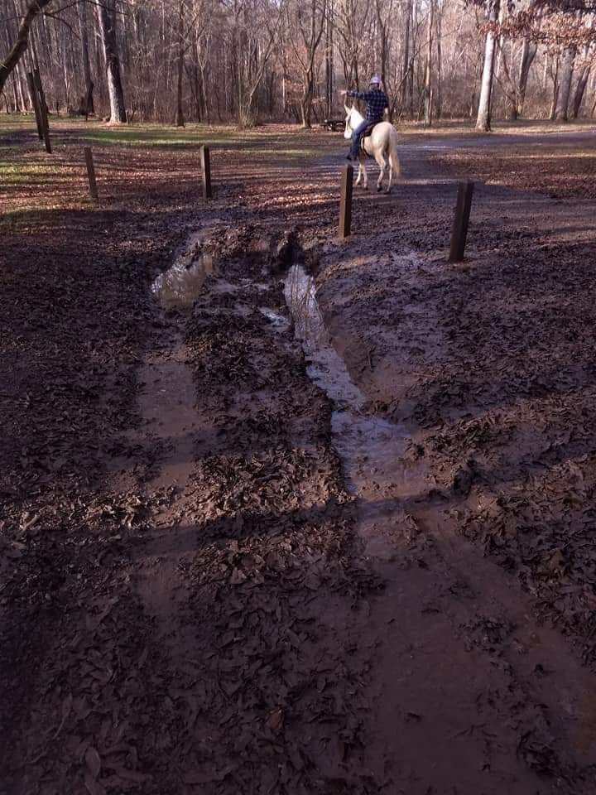

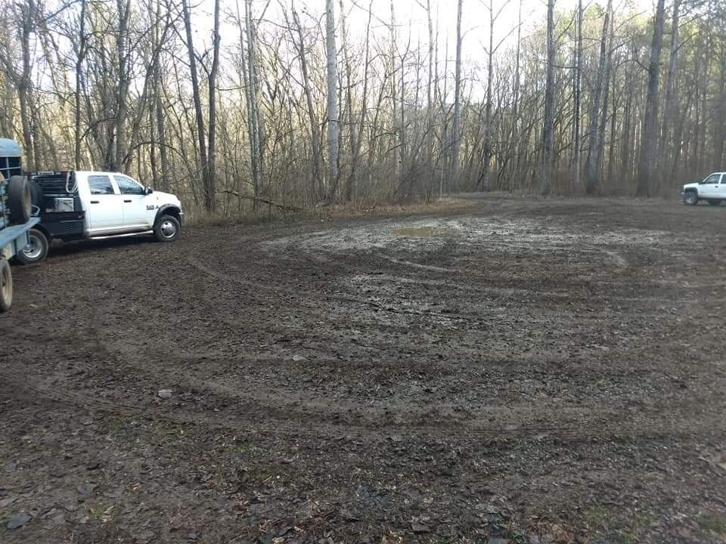
ENFORCEMENT OR EDUCATION

The year is 2020; the Leave No Trace Program has been around, in some form or another since 1990:
Tread Lightly, Light on the Land,
Leave No Trace
As each new program came along, the outdoors enthusiasts embraced the concept with renewed ambitions and ideas. Volunteers from every corner continue to work to “save the resource” spending huge amounts of personal time, monies and energy to keep the conditions of our National Forests ,Campgrounds , and Wilderness areas open to the public. We may not agree with each other, or the Agency in charge but we do agree that this maybe our last shot at keeping Public Lands Public.
Dwindling Agency budgets lead to smaller work forces, lower moral, and fewer services across the board.
The battle cry of the frustrated and overworked volunteer – What are they doing with our Taxes?????
I can’t answer that question nor will I try. Suffice it to say that those questions need to be addressed to our Representatives. We must continue to volunteer, and keep a positive attitude towards our resources. I firmly believe that Education is a much more effective tool than Enforcement. However, I also firmly believe that
YOU CAN’T FIX STUPID and enforcement becomes the only effective tool. Nuff’ said.
COOKS CORNER

TRAIL BOLOGNA
Submitted by BOB WAGNER
Prep time 25 hours.
2 lbs. Ground Venison
2 T. meat-cure salt
2 tsp. Mustard seed
2 tsp. black pepper
2½ tsp. Red pepper
¼ tsp. Garlic powder
1/8 cup water
1tsp. liquid smoke
Combine all ingredients, cover and refrigerate for 24 hours.
Shape into rolls. Bake for1 hour at 300 degrees. Let cool
Refrigerate / Enjoy

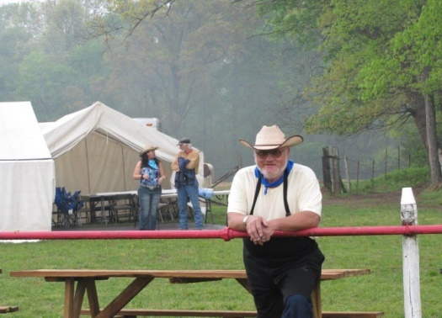
Submit your favorite Trail Snack recipe: horsepacker47@ yahoo.com

I hope to see each and every one of you out on the Trails.

Horsepacker

